Technical Specifications: Organic Waste
Document Number: 574

- Purpose
This document provides technical specifications for disposing of noninfectious, nonhazardous wastes.

- Scope
Organic waste could include kitchen waste, food scraps or infectious waste such as cotton dressings that have been disinfected. This document contains basic information and operational parameters for three types of composting.
It does not deal with biodigestion (anaerobic digestion) or infectious waste. These are covered in a separate document.

- Definitions
Aerobic composting - the breaking down organic matter to form compost through the agency of bacteria and other organisms which depend on oxygen
Food waste - kitchen waste, food scraps
Organic waste - in this document is the part of the waste stream that is biodegradable. This means it can be broken down by biological activity, such as by micro-organisms (e.g., bacteria, fungi, etc.) and by bigger organisms such as worms.
Vermiculture - the breaking down of organic matter by earthworms to form worm compost (also known as vermicompost)

- Responsibilities
  - Management
    - Ensure that the waste management staff are properly trained in operating and maintaining organic waste treatment systems
    - Provide appropriate protective equipment for staff
    - Ensure that the necessary tools and materials are available for the construction, monitoring and maintenance of the organic waste treatment technologies
    - Regularly inspect organic waste disposal systems, report to the waste management committee and implement their recommendations
    - Rapidly respond to and mitigate problems reported by waste handlers.
    - Ensure that compost is used appropriately. It is not recommended that compost made from disinfected wastes be used on food crops or away from the hospital site.

  - Waste handlers
    - Attend training as directed by management and carry out duties as per training
    - Report to management if waste treatment systems are becoming full and new capacity is needed.
    - Conduct any maintenance within you capabilities and responsibilities
    - Report without delay to management any problems that are beyond your capability or responsibility to solve.

- Materials and Equipment
  - Pit disposal
    - Digging implements
    - Fencing materials
    - Wire mesh for it closure (see diagram below)
    - Bins and/or buckets with lids for transporting waste and compost
    - Garden forks or other implements for handling waste and compost
    - Protective equipment: gloves, boots, overalls
  - Aerobic composting
    - Composting bins or bays, usually made from concrete, plastic or wood.
    - Bins and/or buckets with lids for transporting waste and compost
    - Garden forks or other implements for handling waste and compost
    - Protective equipment: gloves, boots, overalls
  - Vermiculture
    - Worm bins, usually made from concrete, plastic or wood.
    - Bins and/or buckets with lids for transporting waste and compost
    - Garden forks or other implements for handling waste and compost
    - Protective equipment: gloves, boots, overalls

- Hazards and Safety Concerns
  - Generally, treatment of organic waste is not a hazardous operation. However there are some general issues that should be taken into account. First, good segregation is essential to ensure that no infectious, sharps, toxic or other hazardous wastes enter this waste stream.As a final method of preventing the spread of any microoganisms that might be in the waste, it is recommended that any compost produced be used only within the hospital and that it not be used on any food crops that might come into contact with the soil and that are eaten uncooked.
  - Physical injury: lifting weights, etc.
  - Pests and feral animals: if not properly protected, food and other organic wastes can attract pests and feral animals including rats, cats and dogs. They can bite people or spread disease. Measures should be taken to keep them away from the waste treatment area.

- Procedures
  - Choice of system
Select an organic waste disposal system that suits local conditions. For example, extremely hot summers or cold winters may make the use of worm composting (vermiculture) impractical as they become inactive or die at extreme temperatures. In theory this problem can be avoided by housing the composting system indoors, and maintaining it within suitable temperature ranges. However, this is likely to be too expensive in most situations. The descriptions below list some parameters that should be considered.
  - Siting of system
    - Because the composting system does not deal with infectious waste, its siting is not so critical. It should be located outside any hazardous waste zone to prevent any hazardous or infectious waste being put into the system.
    - Pit systems should be sited away from areas prone to flooding and at least 1.5m above the water table. To test this, drive a metal pole into the ground, 1.5m below the depth of the planned pit. If the end is wet when it is removed, the pit should be dug more shallowly.
    - All systems should be protected from access by unauthorized persons, and pests.
  - Types of organic waste disposal system
    - Pit disposal
This is suitable only for small facilities that generate just a small amount of waste. Waste quantities should be small enough that the pit is able to contain all the waste for at least two years.

Figure 1: WHO design for burial pit (Pruess et al. 1999)
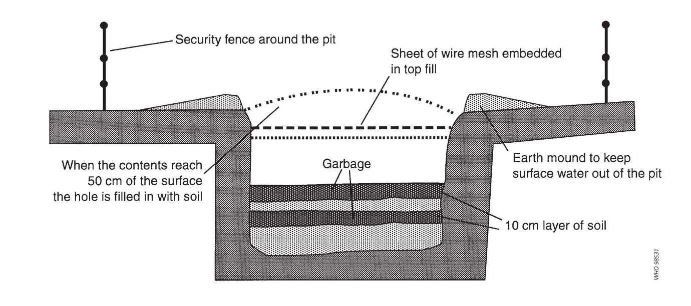

Simple pit design:

Pros | Cons
Cheapest option | Should only be regarded as an interim method
If only used for organics, will not create a long-term hazard

Figure 2: MSF placenta/organics pit design. See related document on placenta pits for information about construction.
Pros | Cons
Can also be used for placenta and pathological waste | Harder to construct and possibly more expensive than above-ground composting if no infectious waste disposal capacity is needed

    - Aerobic composting
This is a process by which microorganisms break down organic matter in the presence of oxygen. More information can be obtained from the FAO website, http://www.fao.org/docrep/007/y5104e/y5104e05.htm.
A well-balanced compost heap will not need any additives, but if it contains materials that are slow to decompose (e.g., those containing woody or other lignin-containing materials), or consists mostly of one type of waste, activators or accelerants may help. These may contain either a solution of microorganisms and enzymes, or nitrogen-containing nutrients. Bins can be of many shapes and sizes; a minimum size of 1 cubic meter is recommended to ensure stable conditions. Practical Action provides directions for making concrete bins (see below).

Concrete bin from Practical Action
(http://practicalaction.org/document-library-6)

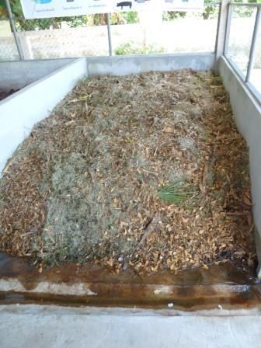 | 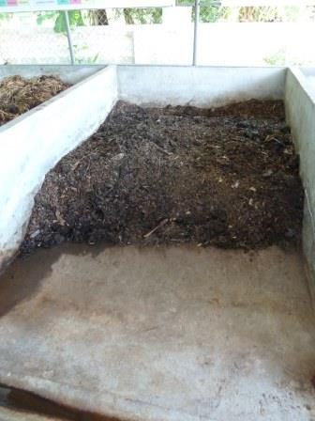
Adjacent composting bays at a hospital in Thailand: on the left, with recently collected waste and on the right, with compost ready to use

Pros | Cons
Economical, produces compost | Food waste can attract pests if the composting materials are not well covered

    - Vermiculture
Vermiculture is the practice of using worms to break down waste. Worms can break down some wastes such as bandages, which would not normally be composted. Research from India (Mathur et al. 2006) suggests that vermicomposting of this waste (soft waste) also results in the removal of pathogens. However, until more research has been carried out to confirm this, it is recommended that vermiculture is not relied upon as a method of treating infectious waste.

Pros | Cons
Can also be used for soft waste (bandages, etc.) once they have been disinfected through autoclaving | Vermicomposting systems must be protected from frost. Most commercially available worms work best between 15-25°C. Perionyx excavates is suited to tropical temperatures.
 | Some ecosystems do not contain worms and the introduction of worms from other countries could be detrimental.

- Reporting and Recordkeeping
  - Amounts of waste composted should be reported in the waste log;
  - Any accidents or incidents should be recorded according to standard procedures;
  - The waste manager should be informed of any equipment, PPE or maintenance requirements, including whether the system is reaching capacity.

- References
  - Prüss A, Giroult E, Rushbrook P, editors. Safe management of wastes from healthcare activities. Geneva: World Health Organization; 1999. http://www.who.int/water_sanitation_health/medicalwaste/wastemanag/en/
  - Mathur UB, Verma LK, Srivastava JN. Effects of vermicomposting on microbiological flora of infected biomedical waste. ISHWM 2006;5(1):28-33.

- Related Documents
Doc 573: Technical Specifications: Biogas Digesters
Doc 575: Technical Specifications: Placenta Pits

- Attachments
None

