Model HCWM Systems for Each Facility Type
Document Number: 571

            - Purpose
This document provides guidance on waste treatment requirements for the range of facilities.

            - Scope
This document focuses on waste that has hazardous properties requiring reduction of the risk to people and the environment before disposal. However, much of the waste that is generated by health care facilities is recyclable and this should be factored into the design of waste treatment facilities.
Health care facility classification is important as it provides insight into the types, volumes and hazards associated with the waste generated. Clinics will generate low volumes of waste, usually with small amounts of infectious wastes, sharps and pharmaceuticals. Hospitals will generate larger volumes due to the number of patients cared for, the size of the facilities and equipment requiring maintenance, as well as the technology and medication used for treatment, for example radiation therapies from oncology wards. The hazardous waste generated by these facilities requires stricter control and higher levels of treatment to reduce the risk to people and the environment. Rural facilities are less likely to have infrastructure required for collection and treatment of hazardous wastes, so appropriate treatment will need to be undertaken on site.
Options are given for rural and urban facilities of different sizes.

            - Definitions
Burn treatment—incineration of health care risk waste to disinfect the waste. This is considered old technology and generates hazardous wastes in the process (ash and gaseous emissions). Modern incineration technologies (such as plasma, pyrolysis and gasification) heat the waste at high temperatures in one chamber with less oxygen present than the old type of incinerators, then burn the waste gases in a separate chamber connected to a smoke stack. The short track record of these newer incinerator technologies has shown that dioxins, furans and other toxins are formed in these systems, and in some cases, toxins are formed in higher quantities than in conventional mass-burn incinerators.
Non-burn treatment—technologies operate at temperatures that are high enough to kill microorganisms but insufficient to cause combustion, thereby avoiding the creation of toxic byproducts like dioxin. There are many types of non-burn treatment to disinfect healthcare risk waste, including:
  - Wet heat—autoclaving, microwaving, hydroclaving
  - Dry heat —uses neither water nor steam, but circulate hot air or use radiant heat;
  - Chemical—e.g., alkaline digestion
  - Most of these non-burn treatment systems are considered to have significantly less environmental impact than those from burn treatment. Some may be expensive to install and maintain, while others involve lower cost systems.
Disinfected health care risk waste – treated to inactivate micro-organisms to reduce the risk from infection and the spread of disease. Use the STAATT criteria for health care waste: Minimum requirement: Level III
Reduction of vegetative bacteria, fungi, lipophilic/hydrophilic viruses, parasites and mycobacteria by 6 Log 10 or greater and the reduction of heat resistant spores by 4 Log 10 or greater.

            - Responsibilities

  - The management are responsible for ensuring that:
- Sufficient budget is allocated for the construction, maintenance and operation of the waste treatment center
- The staff operating the center are properly trained
- Staff operating the center have adequate PPE and other safety equipment
- Staff working in the center and/or coming into contact with the medical waste are vaccinated
  - The waste manager is responsible for ensuring that:
- The day-to-operation of the center goes smoothly
- Trouble-shooting any problems that cannot be solved by the staff
- Informing the waste management committee/senior management about any problems that require their intervention to solve
- Making regular reports on the running of the center to the waste management committee
- Any instructions regarding the waste treatment center from the senior management and/or waste management committee are implemented
  - The waste treatment staff are responsible for ensuring that:
- The center and its equipment are operated cleanly, safely, and according to standard operating procedures
- Waste is treated within the required period (24 hours in hot season and 48 hours in cool season unless there is refrigeration)
- Records and logs are correctly filled in
- Incidents, accidents and breakdowns are promptly reported

            - Materials and Equipment
The following plants or pieces of equipment are used for dealing with wastes from Healthcare Facilities. Depending on the size and location of the facility, the choice will need to be appropriate for that situation. Where existing Healthcare facilities are requiring treatment, it is also important to find equipment that is able to be retro-fitted and can be installed within the available space.
- Autoclave or other non-burn system for treating infectious waste, to render it disinfected.
- Biodigester – anaerobic/facultative biological systems for digesting solid and liquid wastes that are organic in nature, such as sewage and kitchen wastes.
- Bins, bags and containers: to hold and transport waste. The size number and nature will depend on the amount and type of waste being handled.
- Macerators are used to shred soft solids to enable the resulting material to be discharged to sewer. They are not recommended for all situations, due to the potential for generating infectious aerosols during use and blocking of drains and pipes. They are expensive and difficult to maintain.
- Needle cutters/clippers remove the needle from the syringe, reducing the risk from recapping needles or syringes with needles being recovered and reused. It also reduces the volume of infectious and sharps wastes requiring treatment because the syringe is managed separately. Devices have been designed to cut the syringe needle at the base and enclose the needle securely in a puncture-resistant container, with the whole unit suitable for autoclaving when full.
- Needle pit - for disposal of needles where few are generated and no suitable alternative exists.
- PPE to protect workers from hazards – appropriate to the risk, kept clean and in good repair. See related documents for more information.
- Placenta pit – for disposal of placentas where no suitable alternative exists
- Shredder – for rendering treated waste unrecognizable (a legal requirement in some countries) and unable to be reused (especially in areas where illegal drug use is prevalent).
- Tissue digester – for treatment of pathological or tissue waste, such as limbs and placentas, and some waste pharmaceuticals. Uses hazardous (e.g., caustic) chemicals, so must be able to safely handle and store them and be able to safely treat and dispose of the wastes.
- Wormeries – use of earthworms to make compost from organic wastes and disinfected (autoclaved) soft wastes, such as dressings and gauze. The compost can be used to condition soil and fertilize gardens in the facility but at this stage, it is not recommended for use in the community.

            - Hazards and Safety Concerns
There are several hazards associated with the treatment of waste including:

  - Hazardous substances, such as the chemicals used in cleaning, laboratories, etc. Also hazardous are substances used in maintenance and the workshops, including waste oils, used lighting, asbestos from the demolition of older buildings and replacement/upgrading of infrastructure.
  - Infectious material generated from areas where patients are cared for, including toilets and ablution facilities, as well as laboratories and blood donor areas.
  - Biological waste treatment methods described in this guidance can produce solid and liquid residues that are high in plant nutrients. Available research indicates that they will kill almost all pathogens, but more testing is needed and at this stage it is recommended that the residues are not used as fertilizer either on food crops or outside the facility grounds.
  - Sharps from all areas where needles, lancets, glassware etc. are used and the wastes may be stored.
  - Radioactive material such as from oncology wards and those areas using isotopes
  - Toxic substances, including pharmaceuticals, solvents cleaning agents, etc.

            - Procedure

  - Treatment technology selection
The wastes generated by a health care facility need to be considered in an integrated manner to ensure that when they are managed, the risk is not transferred from one medium to another. The waste treatment considered needs to be appropriate, in terms of:
- Size and location of the facility
- Waste types and volumes
- Treatment effectiveness
  - Will the process be appropriate for the level of treatment required?
- Risk to people and the environment
- Energy and water demand
  - Is there a reliable and affordable source of power/energy for the technology?
  - Can alternative and renewable energy sources be used?
  - Is there sufficient water of the quality required? If not, can it be treated?
- Skill requirements and availability
  - Are there skilled people in the area who will be able to operate/maintain/repair the equipment?
- Capital and operating costs
- Infrastructure requirements, both on- and off-site
- International, national and legal requirements
- Reliability of the technology
- Treatment efficiency
- Volume and mass reduction
- Cultural and societal acceptability
  - There may be local, cultural traditions that need to be considered when dealing with certain health care waste streams. In some societies, it is customary to take home and bury placentas and even cook them. It is advisable to consult widely with stakeholders before regulating the treatment and disposal options of these waste streams when dealing with sensitive issues.
- Locally available treatment and recycling options
- Locally available final disposal options
- Available space
- Does the treatment generate other wastes that may be hazardous (to air, water or land)? Can these wastes be treated effectively to reduce risks to people and the environment?
- Can useful by-products be obtained from treating the waste?
- Will the treatment capacity be sufficient:
  - For the foreseeable future (linked to the facility’s future plans)?
  - If there is a change in the amount of waste generated, such as during an epidemic or a health care campaign?
- Is there sufficient storage capacity for unexpected interruptions in treatment (work or equipment stoppage)?
  - Treatment options may include:
- Autoclaving infectious waste
- Biodigesters for treating solid and liquid wastes to reduce pollutant load and generate energy
- High rate algal ponds for tertiary treatment of sewage for disinfection to generate good quality water for reuse and algal by-products as a nitrogen source
- Needle pits for small, rural, non-bedded facilities with no feasible treatment alternative
- Placenta pits for small, rural, non-bedded facilities with no feasible treatment alternative
- Septic tanks with French drains for treating organic liquid wastes (sewage, blood and blood products, laundry wastewaters) for small facilities in areas suitable for this disposal
- Stabilizing/immobilizing hazardous chemicals
- Alkaline digesters for pathological waste, with low-cost systems available for remote facilities.
  - The following table is a guide for waste treatment and disposal options for various types of facilities. Remember that the waste hierarchy must be implemented for all waste streams. Waste streams can be avoided or minimized, as long as the risks have been assessed and mitigated from all the hazardous waste streams. Examples of avoidance include the use of nonmercury products, such as digital thermometers and sphygmomanometers. The table presumes that non-bedded rural facilities are clinics that do not generate large volumes of wastes requiring treatment or disposal. For further details, refer to the Reference Section (9) or Related Documents Section (10).

Wastes |  |  | Rural |  | Urban
 |  |  | Bedded | Non-bedded | Bedded | Non-bedded
Glass sharps |  |  | Dispose of in a sharps pit (small amounts) or landfill |  | - Dispose of to landfill.  - May be recycled if not contaminated.
Infectious | Solids | Anatomical wastes (visibly human tissue) | Bury or treat as you would a dead body if laws or customs require; otherwise treat as pathological waste
Infectious | Solids | Pathological (body parts, tissues, placentas, etc.) | Biodigester, where not available, use placenta pit | Placenta pit | - Biodigester or tissue digester  - Maceration and discharge to sewer also possible in larger facilities where proper maintenance and protection against possible exposure to aerosolized particles is possible.  - Deep burial in landfill if these are not available.  - Incinerate only if dictated by legislation
Infectious | Solids | Syringes | Remove needle from syringe using needle cutter. Autoclave plastic syringe body and recycle if possible. Landfill if recycling is not possible. Treat needle as infectious sharps waste (see below).
Infectious | Solids | Sharps - metal. Syringe needles, lancets, scalpel blades etc | As for urban facility, but if not available, dispose in a needle or sharps pit |  | Contain, autoclave if required by law and send for metal recycling at an authorized facility.
Infectious | Solids | Lab samples (tissues, biopsies,etc) | Samples that do not contain preservatives should be autoclaved in the laboratory, then discarded as general waste or processed so the glassware can be reused. Those containing toxic preservatives such as formalin, should be drained, the solids contained for landfill, and the liquids sent for treatment.
Infectious | Solids | Dressings & other soft waste | Autoclaved, then disposed of in wormery if available or landfilled.
Infectious | Liquids | Blood and body fluids | - Discharge to biodigester,/septic tank or discard in a Placenta Pit for small volumes.  - Discharge to sewer if connected to authorized Wastewater Treatment Works.
Infectious | Liquids | Liquid cultures & stocks | Autoclaved in the laboratory, then discarded to drain as liquid waste.
Infectious | Sewage (urine & feces) |  | Discharged to sewer if authorized Wastewater Treatment Works discharge available. Treated in Biodigester or Septic tank with French drain.  Biodigesters should only be used if the waste has a low content of disinfectants and other toxic materials.
Hazardous Substances | Liquid |  | Small amounts to drain once neutralized, larger volumes to be collected and returned to supplier or central treatment facility.
Hazardous Substances | Cytotoxic and cytostatic drugs |  | - Chemically neutralize residues in giving sets and empty vials etc. before disposing to drain.  - For larger quantities, ideally return to supplier. Send for centralized treatment if the law requires.
Hazardous Substances | Pharmaceuticals (unwanted or expired) |  | - Return to supplier.  - If not possible, encapsulate and inertize, then landfill.  - Send for centralized treatment if the law requires.
Hazardous Substances | Solid (including empty hazardous containers) |  | - Return to supplier, including nominally empty containers – do not landfill unless there is no alternative. In this case, crush or puncture containers to prevent reuse, then dispose of in a landfill.  - Workshop/maintenance wastes – contain and pretreat as per legal requirements for disposal in a landfill designed for hazardous wastes.
Hazardous Substances | Gas |  | Regulated gases e.g., ozone-depleting gases (HCFCs), should be collected and returned to supplier; others vented in small quantities.
Hazardous Substances | Heavy metals (e.g. mercury from broken/redundant equipment) |  | Safely contain, store and transport to central collection site for treatment prior to safe disposal, as per legal or WHO requirements.
Hazardous Substances | Radioactive materials |  | Delay to decay for small quantities of short-lived isotopes. Return sealed sources to suppliers. Otherwise, safely store and send for treatment as per national and International Atomic Energy Agency (IAEA) requirements.

  - Treatment center layouts
There are many ways in which treatment centers can be laid out to meet the needs of the facility they serve, and the available space/buildings available. All should include the following:
- A layout that keeps clean and dirty areas and materials separate at all times. There may be separate entrances and exists for infectious and noninfectious wastes, and transportation routes should be arranged so that they do not cross.
- Fencing or other means of limiting access so that only authorized personnel can access the facility and that pests and feral animals are kept out.
- Weather protection. Even the smallest treatment facility needs to be protected from sun, wind and rain, and excessive heat and cold. Staff should be able to work without undue exposure to the elements.
- “Dirty” storage area for waste awaiting treatment. Note that different storage areas will be needed for wastes exhibiting different hazards (e.g., infectious and toxic wastes will be stored and treated separately).
- Waste treatment area: again, infectious waste should be treated in a separate area to wastes with other types of hazard.
- Post-treatment storage/handling area. Treated waste needs to be stored separately from untreated waste until it can be taken for recycling or disposal.
- Clean and lockable supply storage. This is for unused consumable items such as plastic bags, cleaning materials and PPE. They need to be readily accessible whenever they are needed, but kept secure to prevent theft.
- Equipment washing area. This is for waste collection bins, etc. Washing areas should be sealed, e.g., with ceramic tiles to make it easy to keep the area clean, and have both running water and good drainage. A domestic shower base with flexible hose provides a good low-cost washing option.
- Staff toilet and washing area. This should be separate from the equipment washing area.
- Office/staff locker room/rest area.
  - Staff members each need a locker to keep personal items and clean clothes safe while they are working.
  - A separate storage for PPE should be provided so that it can be kept safe and where there is no possibility of contamination of personal possessions.
  - Adequate space should be provided for record-keeping and other administrative work to be carried out and for records to be stored. In smaller facilities, this may be part of another office area, rather than part of the treatment facility
  - Staff need somewhere to rest during break times. In larger facilities, it may be worth including a tea room for this purpose.

The following diagrams are examples of plans for layout of health care waste treatment facilities.
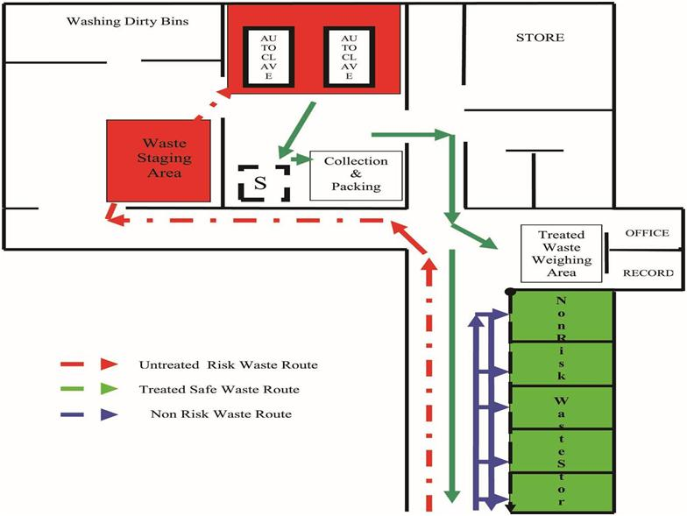
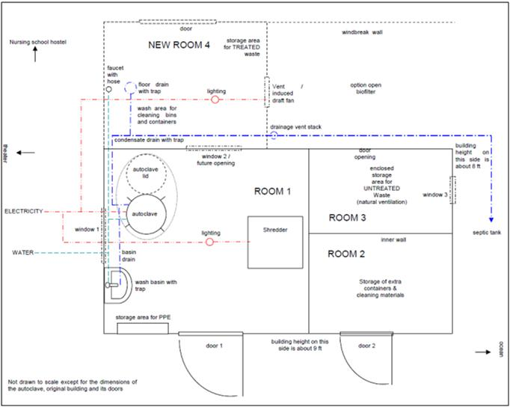
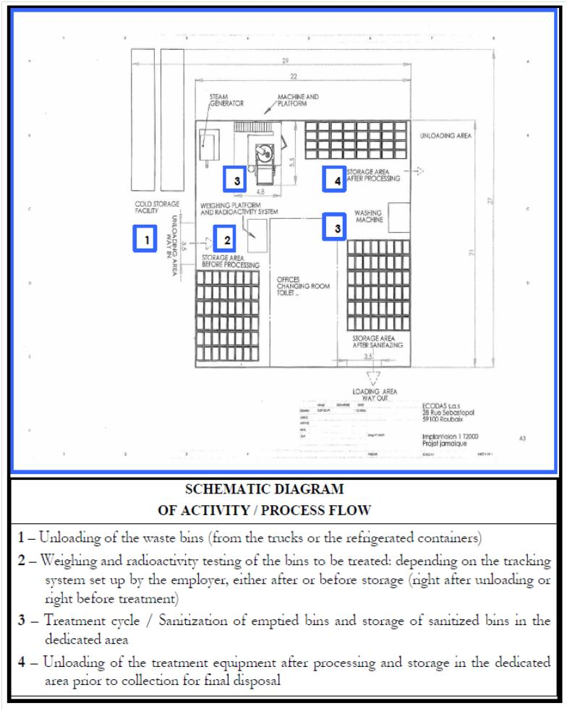
Schematic Diagram of a Jamaican Regional Healthcare Waste Treatment Facility (from Hylton N, 2010 )

The diagram on the previous page shows the layout for a regional Healthcare Waste Treatment Facility in Jamaica (Hylton N, 2010). It treats infectious, sharps, and pathological wastes. Over the period from January 2009 to April 2010, it treated just over 300,000 tons of medical waste from a total of 41 health care facilities. The treatment facility comprises:
- Pre-engineered treatment plant building of approximately 462 m2
- Steam sterilization and shredding treatment system rated at 200 kg/hour with associated accessories and equipment including:
  - Electric broiler – to provide a source of steam for the treatment equipment
  - Radioactive detection device – fitted with an alarm system to prevent any radioactive waste being processed in the facility
  - Cooling system – to reduce water consumption
  - Spare parts – minimum stock of mandatory parts, including an additional shredder
- Mechanical washing system to sanitize storage bins before returning them to health care facilities
- Weighting platform/machine of 500 kg capacity fitted with (non-slip) stainless steel access ramp, indicator and transmitter connectable to a computer and label printer to weigh waste upon arrival at the facility
- Refrigeration containers, to be used for the temporary storage of pathological waste in the event of equipment down time
- Back-up power generator and water storage tanks
- Roll-on/roll-off container for transfer of sterile treated waste to the landfill
- Truck-washing platform integrated with an oil/water separator wastewater treatment system
- Specialized collection vehicles with a payload capacity of 5,000 kg
- Waste storage bins of 770 liters
  - Containers
    - Choose the right container for the waste or use, for example:
- Wet – leak-proof, not wet-able materials (e.g., cardboard)
- Bulky – big containers with wide-mouthed opening
- Not for recycle/reuse – one-way or lockable openings which prevent retrieval of waste
- Smelly – tightly sealed lid
- Hazardous – use the correct color-coding and labeling, according to local or internationally recognized requirements
- Hands-free use – foot-pedal bins
- Sharps – puncture proof
    - Reusable versus disposable containers
- Reusable: reduce the impact associated with manufacture and disposal, by being able to be used many times over. They will need to be effectively cleaned and where necessary, disinfected, before being reused in certain areas. The cleaning routine must include regular checks to ensure the container is clean and is in a good state of repair.
- Disposable: are usually made of lighter materials, which make transport cheaper. They are also cheaper to buy, but the cost of disposal is not included in the overall cost.
    - Identify the categories of waste by:
- Sorting the waste into color-coded containers or bin liners (plastic bags)
- Using posters and signs to show waste generators what waste goes where
    - Establish a routine collection program to ensure that wastes do not accumulate where they are generated.
- Replace waste containers when they are ¾ full.
- Ensure that all containers are closed (e.g., lids sealed, liners knotted or tied).
- Label each container with the generation date, location (hospital and ward or department), contents and type of hazard (infectious, sharps, cytotoxic).
- Collect waste as frequently as required and transport to the central storage site.
- Replace the containers or liners immediately with new ones of the same type.
- Ensure that there is sufficient supply of new collection bags or containers at each generation site.
  - Storage at the central site
- Store health care waste within the facility’s perimeter, not too far from the generation points but away from food storage and preparation areas.
- Allow sufficient space for separate storage of general (nonhazardous) and hazardous waste, as well as that which is to be sent for recycling/reuse.
- Provide easy access for waste collection vehicles. For larger, urban facilities, this access must accommodate larger, longer vehicles and a staging area, where they can wait for documentation or access. Remember that some vehicles collect more than one skip and need space to lift, so require a flat, hard surfaced area with no height restrictions.
- Restrict access and signpost to explain what can be stored, the hazards, PPE requirements and any prohibitions (no smoking, eating, etc.), with contact details for emergency response.
- Cover to protect waste from the elements (heat, wind, rain) and from vectors (flies, rodents and other scavengers).
- Have an impermeable hard-surfaced floor that can be easily cleaned and disinfected. Any spillage must be able to be easily contained and disposed of where it can be subsequently treated.
- Ensure a supply of water for cleaning purposes.
- Ensure good lighting and at least passive ventilation.
- Provide a supply of cleaning equipment, protective clothing, and waste bags or containers located conveniently close to the storage area.
- Store the waste stored in bags or containers in a separate area, room, or building of a size appropriate to the quantities of waste produced and the frequency of collection.
- The storage area must include sufficient space for waste when no collection is possible (e.g., extremes of weather, industrial action (strikes), vehicle or treatment breakdowns).
- There must also be sufficient capacity for increased throughput if the facility is planned to expand with time.
    - Unless a refrigerated storage room is available, storage times for health care waste (i.e., the delay between production and treatment) should not exceed the following:
- Temperate climate: 72 hours in winter; 48 hours in summer
- Warm climate: 48 hours during the cool season; 24 hours during the hot season
    - Cytotoxic waste should be stored separately from other health care waste in a designated, secure location.
    - Radioactive waste
- Should be stored in containers that prevent dispersion behind lead shielding.
- That which is to be stored during radioactive decay should be labeled with the type of radionuclide, the date, and details of required storage conditions.
    - Recyclable waste
- Should be stored separately from any hazardous materials. Transportation routes should not have to pass through the parts of a waste treatment center that deals with hazardous and infectious waste. Storage areas should secure and be protected from sun and rain and pests.
- Before designing a waste storage area, consider both the volume of each waste stream that will be generated, and the amount that will be attractive to waste purchasers.
- As a general rule, the best prices will be obtained for waste streams that are clean, well segregated and provided in large quantities.
- Enough space should be set aside to store a significant amount of waste, as waste purchasers may not accept small quantities. For example, in Kathmandu, Nepal, recyclers prefer to pick up an entire truckload of glass vials.
- For large-volume waste streams, e.g., paper and plastics, small bays are the best. So to save money, these can be constructed from reclaimed materials, such as old bed frames. The photo below shows some examples of segregation and storage.
  - Waste treatment layout
When considering the layout for waste treatment, it is important to consider the following:
- Segregation - keep “clean” and “dirty” waste treatment areas separate.
- Refer to the layout diagrams which show how the separation of clean and dirty areas can be accommodated;
- Provide separate rooms or areas for storage of specialised wastes (radioactive, cytotoxic, chemical, etc) which are handled separately to the infectious and general wastes.
- Waste treatment areas should always have a fence to exclude unauthorized persons
- Storage
- Avoid double handling – always use containers for waste, do not discharge to the floor. Double-handling increases cost, work, and the risk to people and the environment.
- Cleaning – the waste treatment areas will need to be cleaned, so ensure that the surfaces that need to be cleaned can be easily cleaned to facilitate hygiene. Tiling is effective, otherwise, concrete floors will need to be sealed and walls plastered and painted. Design the “clean” (treated waste) and “dirty” (untreated waste) areas so that the cleaning wastes are kept separate. The dirty area cleaning wastes will be classified as hazardous, just as the wastes they contain.
- Container cleaning – this area should be close to where the containers are emptied and under cover, to ensure that effective cleaning occurs even during wet weather. Relying on sunshine for disinfection is not sufficient, so chemicals must be used. This requires the cleaning area to be plumbed to a drain and the receiving facility able to deal with biocides or cleaning chemicals chosen with this in mind.
- Design for worst case – although it adds to the initial cost, it is important to design the waste storage, handling and treatment areas to take into account possible emergency situations. These may be related to on- or off-site conditions or activities, such as equipment failure, transport delays, worker strikes and extremes of weather.
- Storage areas must be provided with sufficient capacity to hold waste (treated and untreated) during emergency situations, not only for the times when the system is working well. This will minimize the risk to people and the environment from inappropriately stored waste, whether it be in the temporary storage areas or at the treatment facility.
- Utilities fail and so there must be a back-up in the event of failure of the supply of water (rain-water harvesting tanks) or energy (generator or alternative fuels). Design the buildings to make use of natural lighting and ventilation as much as possible, so that in the event of a power failure, conditions do not become untenable.
- Treatment equipment must be designed to “fail safe,” so that there are no harmful emissions/discharges or conditions that arise during power failures or other incidents.
- Gravity – for liquid wastes discharged to drain for treatment, try to use gravity flow and not pumps to convey the wastes. Not only is this cheaper, but it reduces the risk from electricity failures when sumps can overflow, which poses a risk to disease.
- Hygiene – ablution facilities must be available to ensure that personnel are able to maintain personnel hygiene standards, including a change room on the “dirty” side. Based on risk, at least a hand basin should be provided to maintain good levels of hygiene. A risk assessment should be undertaken to determine what level of response is required, such as an eye wash facility or emergency shower installed to enable personnel to take action following an incident involving untreated waste.
- Proximity principle – keep distances (on- and off-site) as short as possible to reduce the risk from transport incidents.

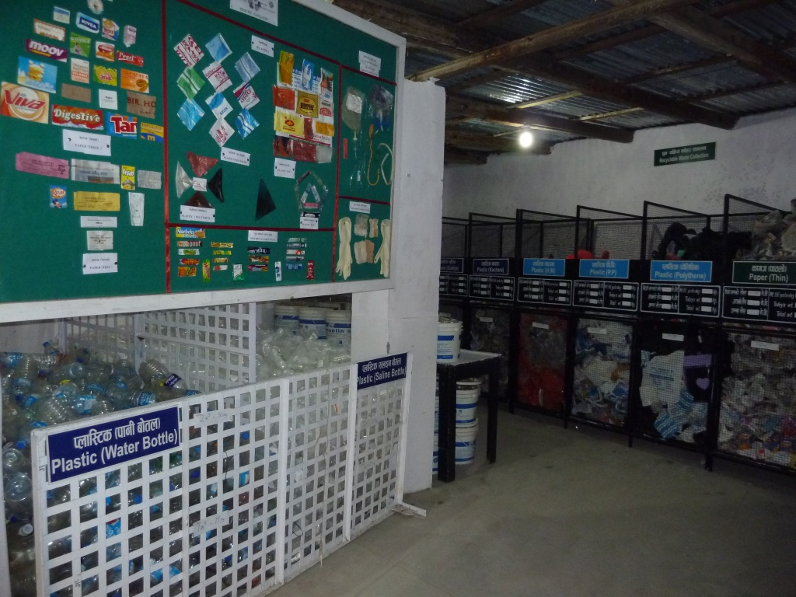
Waste storage bins made from old bed frames (Stringer/HCWH)

            - Reporting and Recordkeeping

  - When considering the installation of new equipment, local legislation must be reviewed for relevant legal requirements. The design and project planning phase for the treatment of healthcare waste treatment is regulated in most countries, either by town planning and/or environmental impact assessment regulations.
  - Records must be kept in compliance with these requirements.
  - The following parameters should also be recorded:
- Waste streams and classification
- Amounts of waste generated, treated, landfilled, recycled/reused
- Details of wastes landfilled (where, when, etc.)
- Off-site transport legs of the waste journey (by whom, when and to where)
- Waste manifests - the uniquely numbered document that is dated and signed by signatures the generator, the transporter and the person of the organization accepting the waste for treatment, landfilling, reuse/ recycle
  - See also documents on the use and maintenance of autoclaves and other equipment, as well as the relevant logs.

            - References
The World Health Organization and United Nations Environmental/Development Programme have many guidance documents which provide good information and tips on how to go about establishing a waste management program. The following references have been used to prepare this document.

  - Gaia (Global Alliance for Incinerator Alternatives) website http://www.no-burn.org/section.php?id=67
  - United Nations Development Programme‒Global Environment Facility (UNDP‒GEF), Global Healthcare Waste Project. Guidance on the microbiological challenge testing of healthcare waste treatment autoclaves. New York (NY): UNDP‒GEF; 2010. 9 p.
  - http://gefmedwaste.org/downloads/Guidance%20on%20Microbiological%20Challenge%20Testing%20for%20Medical%20Waste%20Autoclaves-%20November%202010.pdf
  - Basel Action network website: http://ban.org/library/medical_waste.html
  - Health Care Without Harm Asia. Best practices in health care waste management-examples from four Philippine hospitals. Manila: Health Care Without Harm; 2007. 69 pp.
  - http://noharm.org/lib/downloads/waste/Best_Practices_Waste_Mgmt_Philippines.pdf
  - Prüss A, Giroult E, Rushbrook P, editors. Safe management of wastes from healthcare activities. Geneva: World Health Organization; 1999. http://www.who.int/water_sanitation_health/medicalwaste/wastemanag/en/
  - Emmanuel, J. Elements of a model facility policy on healthcare waste management. New York (NY): United Nations Development Programme‒Global Environment Facility; 2009. http://gefmedwaste.org/downloads/Elements%20of%20a%20Model%20Facility%20Policy%20April%202009%20UNDP%20GEF%20Project.pdf
  - US EPA (2002) Onsite Wastewater Treatment Systems Manual http://www.epa.gov/owm/septic/pubs/septic_2002_osdm_all.pdf
  - US EPA (2003) Voluntary National Guidelines for Management of Onsite and Clustered (Decentralized) Wastewater Treatment Systems, http://www.epa.gov/owm/septic/pubs/septic_guidelines.pdf
  - Stringer R, Kiama J, Emmanuel J, Chenya E, Katima J, Magoma F.(2010) Non-Incineration Medical Waste Treatment Pilot Project at Bagamoyo District Hospital, Tanzania http://noharm.org/lib/downloads/waste/Bagamoyo_Pilot_Project_Report.pdf
  - Whittington-Jones KJ, Rose PD, Leukes W, Lok G, Naidoo S, Lok D. (2009) Development of a knowledge management system for operation of the algal integrated ponding system (AIPS): A training and operations tool for small WWTPs. Water Research Commission, South Africa. http://www.wrc.org.za/Knowledge%20Hub%20Documents/Research%20Reports/TT-372-08.pdf
  - Hylton, N. (2010 ) Implementation of Alternative Medical Waste Treatment Technology In Jamaica, Ministry of Health, Jamaica W.I. Submitted to 5th Biennial Caribbean Environmental Forum & Exhibition June, 2010
  - http://cehi.org.lc/cef5/documents/CEF%20papers%20and%20presentations/PAPERS/Parallel%20Session%201%20RECARIBE%20Meeting%20Waste%20Management/Navarine%20Hylton%20Implementation%20of%20Alternative%20_Non-Incineration_%20Medical%20Waste%20Treatment%20Technology%20in.pdf
  - Other resources available at the Health Care Without Harm website www.noharm.org.

            - Related Documents
- Doc 573: Technical Specifications: Biogas Digesters
- Doc 572: Technical Specifications: Ash Pits
- Doc 576: Technical Specifications: Sharps Pits
- Doc 575: Technical Specifications: Placenta Pits
- Doc 522: On-site Treatment and Disposal of Blood Transfusion Products — Guidance
- Doc 531: Autoclave Inspection and Routine Maintenance — SOP
- Doc 530: Autoclave Operation — SOP
- Doc 532: Autoclave Operation Log
- Doc 533: Autoclave Validation and Challenge Test Log
- Doc 523: Chemical Waste Management — Guidance

            - Attachments
None

